Updated 2023
Green Tukwila Partnership Communication Guide
Green Tukwila Partnership (GTP):
The City of Tukwila joined the Green Cities Partnership, a collaboration of Puget Sound cities working to steward natural open spaces in 2017. Tukwila's program is called the Green Tukwila Partnership. Together with Forterra, EarthCorps, Duwamish Alive Coalition, Partner in Employment, the Service Board, Dirt Corps, King County Parks, and the Tukwila community, Green Tukwila Partnership will care for public parks and natural open spaces across the city. Over the next 20 years, the partnership will work to restore and maintain 138 acres of Tukwila's urban forest.
GTP communication and program oversight for partners and city-led volunteer programs currently sits in the Tukwila Parks Department.
Goal: this guide will streamline best practices for communication with Tukwila Parks and Recreation (TPR) across multiple platforms to celebrate the work happening in the Green Tukwila Partnership (GTP).
Tukwila Parks and Recreation Contacts:
- Green Tukwila Field Phone: 206.806.1596
- Green Tukwila Partnership Coordinator, Olena Perry olena.perry@tukwilawa.gov, 206.799.6474
- Parks Maintenance Supervisor Matthew Austin, matthew.austin@tukwilawa.gov 206.445.2245
Website: www.Tukwilawa.gov/greentukwila
The city website is the landing page for all public and volunteer opportunities in Tukwila. All partner organizations offering programming in the Tukwila Park system or on city property must work with Green Tukwila Partnership and represented on the webpage via Cedar Database. The protocol was created after receiving community feedback in 2018 that finding volunteer opportunities in Tukwila for environmental work needed to be clarified.
Marketing Campaigns
GTP puts out two large campaigns annually, in Spring and Fall. These campaigns include mailers to households, content in the TPR quarterly brochure, park banners, yard signs, newsletters, flyers, and social media platforms. All information that is available on the GTP website will be in campaigns. The GTP Coordinator will reach out before each campaign to collect content. This effort raises awareness of all partner work while supporting volunteer recruitment.
CEDAR Online Database, Volunteer Recruitment Platform
CEDAR is the Restoration database for the Green Tukwila Partnership. All partners will receive login information and are expected to create events, work logs, volunteer lists, and professional crew logs. This collaborative database is used for volunteer recruitment and data reporting within the city on all environmental work. Green Tukwila staff will work directly with you to create the type of account that best fits the situation- steward, partner, etc. Please update and complete data entry monthly.
- CEDAR Link: https://tukwila.greencitypartnerships.org
Social Media Platforms & Digital Marketing
It is essential to share all the great work happening in parks, green spaces, and the watershed. The environmental conversation must be shared and updated among residents, the community, the City Council, and city staff. Folks must see the faces and partners and know who is doing this vital work.
Content & Events on Digital Platforms
- Like and follow @tukwilaparks on FB/IG, and @greentukwilapartnership on FB
  - Easier to tag organizations
- Partners share FB events, reels, stories, and posts on their pages and tag @tukwilaparks and @greentukwilapartnership.
  - GTP can comment, share, and repost.
- At the end of the work party, Send an email or text to the GTP Coordinator with 2-4 photos and a couple of sentences about the work. GTP will post on pages and tag your organization.
- Facebook events make @tukwilaparks and @Greentukwilapartnership co-hosts.
Platforms, Tagging, and Schedule:
- Facebook
  - Tukwila Parks and Recreation @tukwilaparks
    - GTP post on Tuesday, Tukwila Focused
  - Green Tukwila Partnership @greentukwilapartnership
    - Can post daily, regional content and volunteer opportunities in Tukwila.
- Instagram:
  - Tukwila Parks and Recreation @tukwilaparks – posts go out on Tuesdays and during weekend events
- Common Hashtags: #greentukwila #tukwila #volunteer #restoration #planting #parklife #tukwilaparks #duwamish
Newsletters
GTP submits content to multiple newsletters within the city; all content is from the GTP website.
- TPR Email Newsletter: monthly content due by the 25th of each month, goes out on the 1st – 4,500 people
- Hazelnut Print: short blurb goes out via mail to residents every two months (updates for the entire city)
- Hazelnut Email Newsletter: monthly for the City of Tukwila to 1,500 residents- content due mid-month.
Print Marketing- flyers, banners, yard signs
As a partnership, the GTP logo should be on all printed marketing to show collaboration via partners. Use the website as a base for all public and volunteer opportunities under the umbrella of GTP.
- Example: sign up at www.Tukwilawa.gov/greentukwila
The GTP coordinator must approve all flyers with the logo before going live. The reason is to be aware of the brand use, not to control content.
Banners, flyers in parks and green spaces
- All banners and flyers in city facilities/parks must be pre-approved for location; all printable materials must have a plan for installation and pick up of materials. Parks will not pick up expired banners and yard signs.
City Reports:
GTP writes a biweekly report that updates City Council and the Mayor's office on current happenings within Tukwila. Please email the GTP Coordinator 2-3 photos and a few sentences of any programming, crew work, or volunteer events in Tukwila within a week. This report is crucial to ensuring that City Council and the Mayor's office are aware of the impact that is happening year around and the interest from partners and residents in healthy, sustainable parks and green spaces in Tukwila.
Logo:
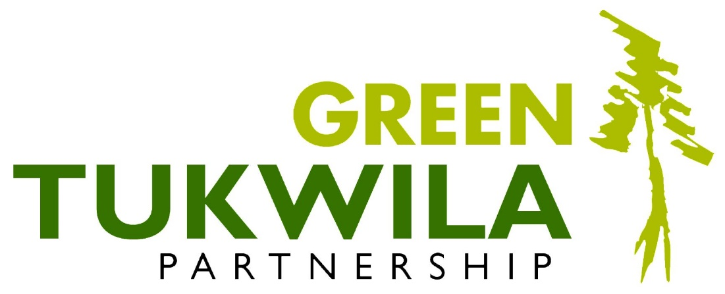
In white:

